Table AX. All fires from FRAP (2017) perimeter database the burned within SCB. Fires included in the analysis burned 57% of SCB.

|  |  |  |  |  |  |
| --- | --- | --- | --- | --- | --- |
| Year | Name | Report date | Total area (ha) | Area of watershed burned (ha) | Included in analyses? |
| 1952 | Sugarloaf | 19-Jun | 15 | 15 |  |
| 1964 | Williams | 2-Oct | 5 | 5 |  |
| 1971 | Ball Dome | 13-Aug | 99 | 99 |  |
| 1972 | Sugar Valley | 15-Sep | 16 | 5 |  |
| 1973 | So. Sentinel | 28-Aug | 1084 | 1038 | Y |
| 1974 | Comanche | 22-Jul | 1219 | 1219 | Y |
| 1976 | In Between | 29-Jul | 13 | 13 | Y |
| 1977 | Sugarloaf | 20-Jul | 264 | 264 | Y |
| 1977 | Ferguson | 26-Jun | 4219 | 1594 | Y |
| 1980 | Roaring | 1-Aug | 170 | 72 | Y |
| 1985 | Sugarloaf | 28-Jul | 1153 | 1152 | Y |
| 1988 | Sugarbaby | 20-Jun | 3 | 3 | Y |
| 1992 | Ellis Meadow | 2-Jun | 23 | 23 | Y |
| 1997 | Sugarloaf | 15-Aug | 114 | 114 | Y |
| 1999 | Williams | 18-Sep | 232 | 232 | Y |
| 2003 | Williams | 28-Jul | 1429 | 1427 | Y |
| 2004 | Ferguson | 7-Jul | 1 | 1 |  |
| 2006 | Pond | 13-Aug | 5 | 0 |  |

# Appendix A: Sugarloaf Creek Basin and Illilouette Creek Basin weather station sites

At Sugarloaf, comparison between manually collected soil moisture data measured in a grid around each weather station site and weather station recorded 12 cm soil moisture was made. For a spring date of May 23rd, 2017, manually collected soil moisture data for wetland, shrub, and forest stations were 48%±13%, 7.5%±1.8%, and 8.7%±2.3% respectively. For the same collection date, the wetland, shrub, and forest weather stations’ 12 cm soil moisture sensors have measured 49%, 10%, and 11% respectively. For a late summer date of August 5th (wetland and forest) and 9th (shrub), 2017, manually collected soil moisture data for wetland, shrub, and forest stations were 41%±14%, 1.0%±0.6%, and 1.3%±1.2%. For the same collection dates, the wetland, shrub, and forest weather stations’ 12 cm soil moisture sensors have measured 49%, 2.2%, and 2.9% respectively. It appears that manually sampled soil moisture is consistently lower than soil moisture data measured by the weather stations. This makes sense since manually collected soil moisture measures average soil water content vertically from the surface to the depth of 12 cm. Meanwhile weather station’s moisture probe measures average soil water content horizontally at the depth of 12 cm.

Differences in weather station vegetation between ICB and SCB do exist. The SCB wetland site contains larger portion of conifer regeneration in comparison to ICB which is predominantly vegetated with tall grasses. The shrubland site in ICB prior to the Empire Fire in the fall of 2017 was comprised mostly of white-thorn (*Ceanothus*). The fire burned the shrub site at high severity, resulting in bare soils with little live vegetation for the following 2018 WY. In comparison, the SCB shrub site contains a dense growth of young conifers with a mix of ceanothus. Forest sites are similar in tree density, tree species, and slope for both ICB and SCB. Refer to Figure A.1 for imagery of SCB weather stations, Figure A.2 for pre-Empire fire ICB weather stations, and Figure A.3 for post-Empire fire ICB weather stations.

On average, SCB is 0.3 degrees Celsius cooler in the summer and 0.2 degrees cooler in the winter than ICB with average summer temperatures of 15.7 degrees Celsius and average winter temperatures of -1.1 degrees Celsius In SCB, the forest station is on average 0.6 degrees warmer than the wetland station, and 0.1 degrees warmer than the shrub station. That difference is even greater in ICB where the forest station is on average 1.2 degrees warmer than the wetland station and 0.3 degrees warmer than the shrub station (see Appendix A for graphical comparison).



**Shrub**

**Wetland**



**Forest**

Figure A.1: Images of weather stations taken by installed snow cameras in Sugarloaf Creek Basin. Top image is of the wetland site, middle is of the shrub site, and bottom is of the forest site.



**Wetland**



**Forest**

**Shrub**

Figure A.2: Images of weather stations taken on October 11th, 2015 by installed snow cameras in Illilouette Creek Basin. Top left image is of the wetland site, bottom left is of the shrub site, and right image is of the forest site.

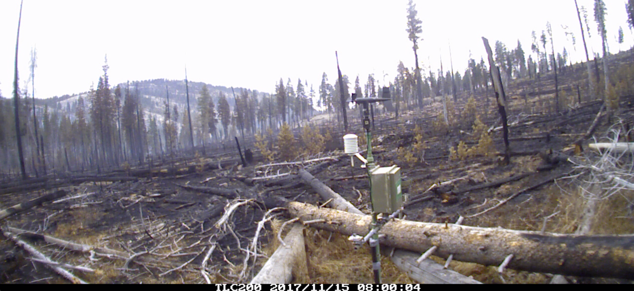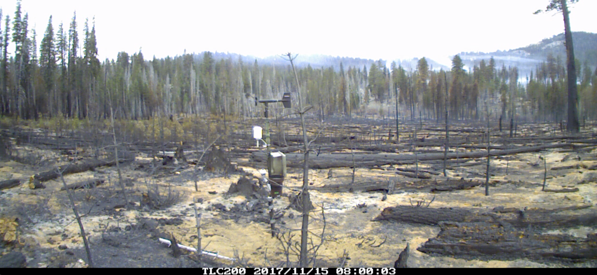

**Shrub**

**Wetland**

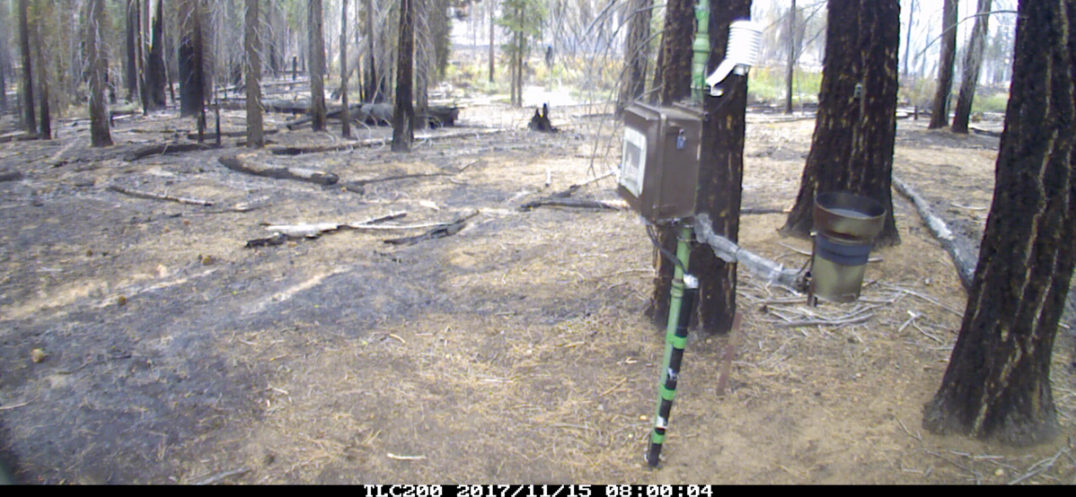

**Forest**

Figure A.3: Images of weather stations taken on December 15th, 2017 shortly after the Empire Fire (August-November 2017) has burned through the area in Illilouette Creek Basin. Top image is of the wetland site, middle is of the shrub site, and bottom is of the forest site.

Similarly to Figure 10 in the Soil Moisture section of Results, figure A.4 provides soil moisture data in ICB at 12, 60, and 100 cm depths as recorded by the wetland, shrub, and forest weather stations. Gray shading signifies presence of snow around weather station’s base for a given time period.



Figure A.4: volumetric water content [%] shallow (12 cm), mid (60 cm), and deep (100 cm) soils as measured by wetland (top plot), shrub (middle plot), and forest (bottom plot) weather stations in Illilouette Creek Basin. Data was measured at 10 minute intervals for part of 2016, 2017 and 2018 water years. Daily precipitation in the form of rain and snow melt is presented as vertical bars. Gray horizontal lines represent period of time when snow is present around the base of the weather station. Water year (WY) summaries are also provided for total precipitation recorded at each station. The Empire fire has burned through the area where the stations were installed, resulting in the prior removal of the station and lack of data for the month of September through November 2017.

Figure A.5 provides summaries of the mean temperature for each month at each weather station for both SCB and ICB. On average, SCB is 0.3 degrees cooler in the summer than ICB, and 0.2 degrees cooler in the winter. For both SCB and ICB, forest station is generally the warmest and wetland station is the coolest year around with the greatest difference in the winter months.



Figure A.5: Mean monthly temperatures for SCB’s (top), and ICB’s (bottom) weather stations for 2017 and 2018 water years for forest, shrub, and wetland stations.

For both ICB and SCB, majority of the precipitation is in the form of snow. Differences in snowpack depth between the three stations was observed (Figure A.6). Sugarloaf has missing snow depth record due to cameras being covered with snow for much of the 2017 WY. However, it is clear that SCB had more snow that winter than ICB. Snow depth was comparable between the two sites during the 2018 WY. In ICB manual snow depth measurements were taken in a grid around each weather station in March 2016, January and April 2017, and March 2018 (Figure A.6). For both locations and all water years, the wetland station on average had the greatest snow depth with the latest melt date, followed by the shrub station. Forest station had the lowest snowpack depth and earliest melt date.

**

Figure A.6: Snow depth (in mm) for Sugarloaf Creek Basin (top) and Illilouette Creek Basin (bottom) as measured from images taken four times each day at wetland, shrub, and forest weather station sites. Additionally, error bars (squares indicating mean, and bars indicating standard deviation) are shown for manually measured snow depths in ICB.

# Appendix B: Precipitation Gap Filling

The first step in obtaining accurate precipitation timeseries was to remove all incorrect precipitation records. This includes times when the rain gauge is upside down or damaged in any other visible way, or when false precipitation measurements are clearly caused by a person or animal moving the gauge (e.g., when maintenance occurred or when time lapse cameras show that an animal disturbed the station). The next step was to set precipitation record as missing for the times when the station recorded zero precipitation, but the surrounding stations have recorded a precipitation event and there was a pulse in shallow soil moisture content. This type of missing data has mostly occurred in the winter months when the tipping bucket was likely to be frozen and/or the rain gauge was covered with snow. After this step, in Sugarloaf Creek Basin, 32% of precipitation at the forest, 25% at the shrub, and 27% at the wetland station was missing. In Illilouette Creek Basin, these percentages were: 24%, 10%, and 19% respectively.

If all three stations were missing precipitation record, then a combination of snow melt amounts and shallow soil water inputs was used to gap-fill the record (Figure B.1). Snow melt was measured as a decrease in snow depth. Snow depth was converted to water equivalent using density of 0.4. and then was rounded to the nearest 0.1 inch to match the resolution of the precipitation gauge. Due to the record snowpack in 2017 water year (WY), we were not able to measure snow depths above the height of the camera (~220 cm) in SCB. Shallow soil water inputs were estimated by smoothing 10-min soil moisture content at the depth of 12 cm, and then depth integrating moisture content over the time series. Positive change was counted as water accumulation, and negative change was counted as water loss. While shallow soil water input metric is not a good approximation for the precipitation amount, it is a good metric to detect precipitation and melt events in the absence of rain gauge data.

In the final step, a predictive mean matching (mice.impute.pmm function in R package “MICE”) was used to perform multiple imputations of the missing data when there was record for at least one station. Predictive mean matching (Little and Statistics 1988) is an advantageous technique for large datasets having non-normal distributions, and discrete values with physical bounds (in our case precipitation cannot be less than zero). Five imputations were performed with a random selection of one observed value from a pool of 5 donors of the closest predicted values. After this step, precipitation record was complete with no missing values. All predictions were rounded to the nearest 0.1 inch (2.54 mm), since that is the smallest measurement detected by the rain gauge.







Figure B.1: Tipping bucket, snow melt, and shallow soil water inputs records for forest (top), shrub (middle), and wetland (bottom) stations in SCB.

**Literature Cited**

Little, R. J. J. J. o. B., and E. Statistics. 1988. Missing-data adjustments in large surveys. Journal of Business & Economic Statistics **6**:287-296.

# Appendix C: Supplemental results

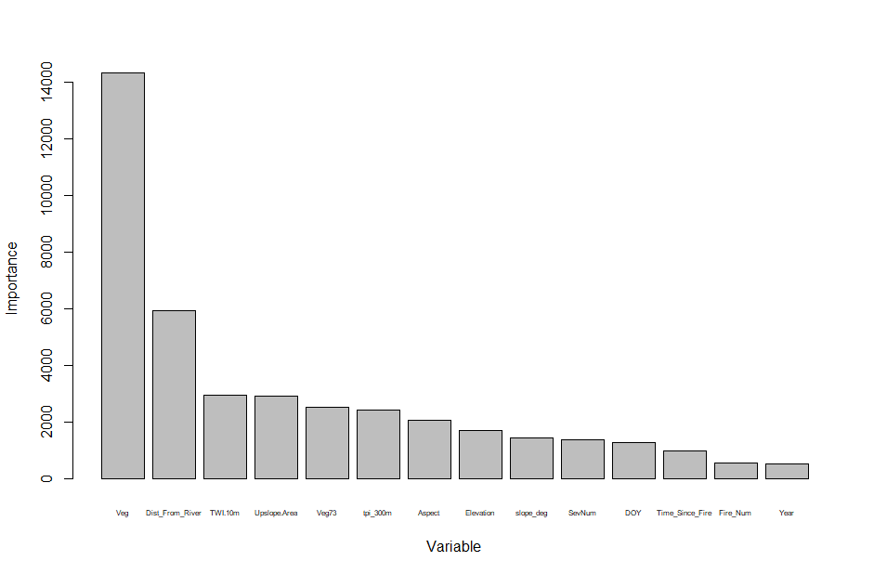

Figure C1: Relative importance of each variable in predicting plot-level soil moisture. Gabrielle can you unpack each variable name in this caption?



Figure C2. Modeled versus measured soil moisture in SCB (site means). Red points are calculated using a model trained on ICB data; black points are from a model trained on SCB data.



Figure C3. Errors in predicting SLB soil moisture using a model trained on SLB data (grey) and on ICB data (red).